- The ‘Evo’ (Evolutionary) Method for Project Management.
- Process Description
- 1. Gather from all the key stakeholders the top few (5 to 20) most critical goals that the project needs to deliver.
- Give each goal a reference name (a tag).

- 2. For each goal, define a scale of measure and a ‘final’ goal level.
- For example: Reliable: Scale: Mean Time Before Failure, Goal: 1 month.

- 3. Define approximately 4 budgets for your most limited resources
- (for example, time, people, money, and equipment).

- 4. Write up these plans for the goals and budgets
- (Try to ensure this is kept to only one page).

- 5. Negotiate with the key stakeholders to formally agree the goals and budgets.

- 6. Plan to deliver some benefit
- (that is, progress towards the goals)
- in weekly (or shorter) increments (Evo steps).

- 7. Implement the project in Evo steps.
- Report to project sponsors after each Evo step (weekly, or shorter) with your best available estimates or measures, for each performance goal and each resource budget.
- On a single page, summarize the progress to date towards achieving the goals and the costs incurred.

- 8. When all Goals are reached: ‘Claim success and move on’
- a. Free remaining resources for more profitable ventures

- Copyright 2011 Tom@Gilb.com. www.Gilb.com
- Permission to Use without cost, citing this copyright notice in your copy, is granted, if you send a copy telling us what you are doing, and a copy of any extensions or variations.

- P1. Gather from all the key stakeholders the top few (5 to 20) most critical goals that the project needs to deliver.
- Give each goal a reference name (a tag).

- Stakeholders: A stakeholder is any person, group or object, which has some direct or indirect interest in a defined system.

- P1A: Brainstorm a Tagged list of critical stakeholders.
  - Internal (development and maintenance of the system), and External (user, buy, evaluate, are affected by the system, can affect the system (laws, policies, regulations)). The list should be 10 to 50 stakeholders depending on size and complexity of the system.
  - Example:
    - New User: a person using the system for first or first few times.
- P1B: Derive a named (Tagged) list of critical requirements, objectives or constraints for each stakeholder (1 to 5 each approximately)
  - Example:
    - New User: a person using the system for first or first few times.
      - Learning Ease
      - Correction Ease
      - Familiarity

- S1. Stakeholder slides (an unorganized collection) http://www.gilb.com/tiki-download_file.php?fileId=318

- P2. For each goal, define a scale of measure and a ‘final’ goal level.

- For example: Reliable: Scale: Mean Time Before Failure, Goal: 1 month

- For example

- Correction Ease:
  - Scale: the average time in seconds to undo and correct any mistake made in this session of work
  - Goal: less than 10 seconds average

- Step Tools:
- (B1.5) Chapter 5: Scales of Measure:
- http://www.gilb.com/tiki-download_file.php?fileId=26

- This chapter of the CE book gives considerable examples of defining scales of measures. Google (‘Correction Ease Metric’) for more.

- For more advanced real examples see:
- S2. Quantified Top-Level Critical Value-Objectives-the main levers of power for CIOs GILB 13 Sept 2011.pdf (3.98 Mb)
- http://www.gilb.com/tiki-download_file.php?fileId=481
- S3. Setting and Tracking Project Objectives (BCS Dec 2010 Talk)
- http://www.gilb.com/tiki-download_file.php?fileId=455

- P3. Define approximately 4 budgets for your most limited resources
- (for example, time, people, money, and equipment)

- The main idea is that we need to be formally aware of these primary constraints when suggesting and designs, architecture, strategies and solutions. All such must fit into these overall resource limitations

- For example:

- Total Deadline:
  - Goal: 1 January 201x

- Financial Budget:
  - Less than 1 million total investment

- Operational Budget:
  - Less than 100,000 annually for all costs

- Literature:
  - B1. T. Gilb, Competitive Engineering, chapter 6 ‘Resources, Budgets and Costs’, page 165 to 184

- P4. Write up these plans for the goals and budgets
- (Try to ensure this is kept to only one page).

- 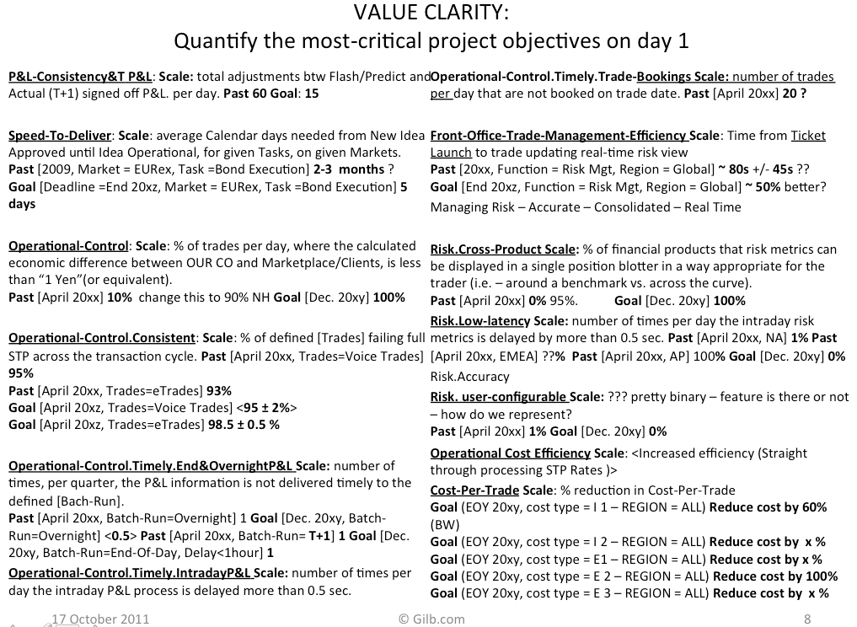

- Source of above example:
- S3. Setting and Tracking Project Objectives (BCS Dec 2010 Talk)
- http://www.gilb.com/tiki-download_file.php?fileId=455
- P5. Negotiate with the key stakeholders to formally agree the goals and budgets.

- Now that the top level project objectives are quantitatively clarified, show them to the main and relevant stakeholders, get corrections, feedback and signoffs (document buy ins and exceptions in the objectives themselves)

- What you expect to find it that the quantified and clarified objectives are not exactly what the stakeholders had in mind. But listen to their corrections to both the definition (Scale) and the level of ambition (Goal level numbers)

- What you are looking for is a set of objectives that will delight, andnot disappoint, and which will justify the project investment. The objectives can be adjusted gradually as you get experience. So, they do not have to be final. Just a pretty good approximation to begin with!

- For example

- Correction Ease:
- Scale: the average time in seconds to undo and correct any mistake made in this session of work
- Goal: less than 10 seconds average
  - Source; Marketing Director and Project Manager approved orally in a meeting on June 22 201x
  - Note: they would both like it much faster, but this is an acceptable improvement <- tsg June 23

- P6. Plan to deliver some benefit
- (that is, progress towards the goals)
- in weekly (or shorter) increments (Evo steps).

- P6.1 Architecture and Strategy
  - P6.1A. Design the top ten strategies, or critical few things you need to do in order to meet the top level objectives. (CE Books, Chapt. 7, ‘Design Ideas and Design Engineering’, pp 187-219

  - P6.1B. Score or rate the estimated impact of those solutions, using an impact estimation table (CE book, chapter 9 pages 263-289). 100% means reaches Goal level on time.
  - 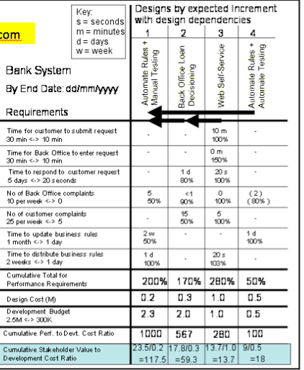

- P6.2 Based on currently do-able (not dependent) elements of these strategies,
  - P6.2A. Select something to do in the next Evo cycle (‘Next Week’) which would arguably deliver some measurable value. (S5, A3)
  - P6.2B Estimate the value it should deliver at end of next Evo cycle (as a % of at least one major objective)
- 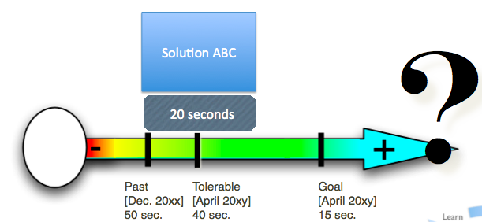Case study of doing this: Confirmit
  - Confirmit Slides ROOTS, Bergen, Norway 2009 i by Trond Johansen
  - http://www.gilb.com/tiki-download_file.php?fileId=278
  - In this case the delivery team themselves brainstorms a number of delivery ideas, and estimates the impact. They then select the idea with greatest impact, for delivery that week.

- P7. Implement the project in Evo steps.
- Report to project sponsors after each Evo step (weekly, or shorter) with your best available estimates or measures, for each performance goal and each resource budget.
- On a single page, summarize the progress to date towards achieving the goals and the costs incurred.

- P7A: Implement all aspects of your selected Evo step that are necessary to get a measurable result in practice.
  - The new code must be integrated reliably into a real (istic) system, and data, people, motivation training must be done

- P7B: Measure in a simple but credible way, the actual impact of the step
  - Rough sampling is often more than good enough.
  - Confirmit budgeted 30 minutes per week for this measurement

- P7C: Report cumulative progress towards critical targets on that step.
- 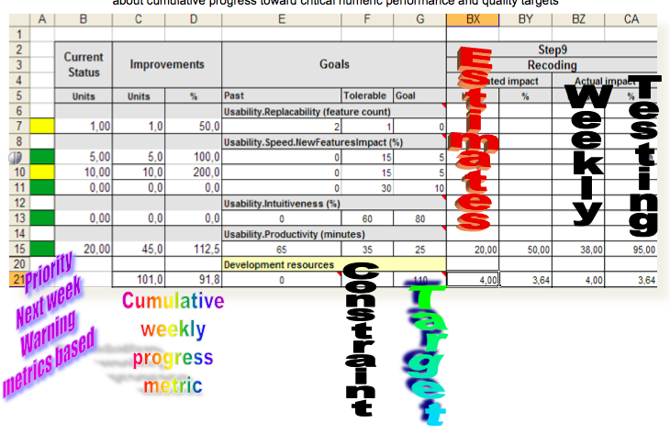

- P7D: learn lessons, as a small group, on the measurable results.

- P8. When all Goals are reached: ‘Claim success and move on’
  - a. Free remaining resources for more profitable ventures

- P8A: stop the project when
  - Either all critical objectives are reached at 100% of the Goal levels. Free remaining resources for other needs.
  - Or
  - No resources remain to deliver any unmet goal levels.

- Paper on the idea of being Done:
- “Done should mean value delivered to stakeholders”
- http://www.gilb.com/tiki-download_file.php?fileId=484

- paper in 4 Oct 2011 Issue of free www.agilerecord.com
- Gilb's Mythodology column

- 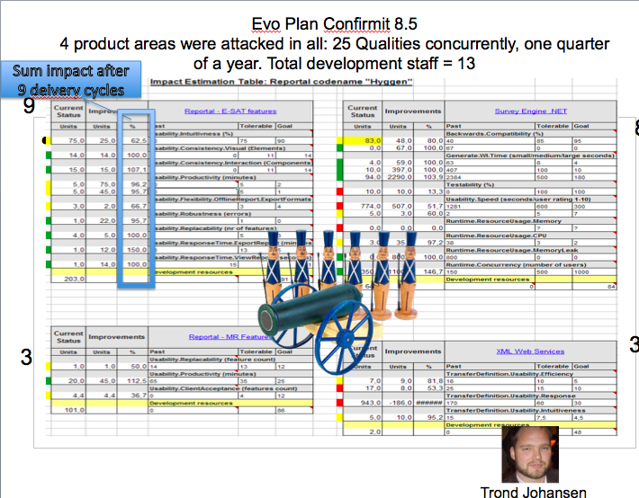
- In this real example, we are 9 weeks through a 12 week cycle of release to the International Market. We have 3 weeks left to work, and the ideal is that each of the 4 parallel teams deliver 100% of all of their Goals. You can see they are largely done, and can now prioritize the few goals under 100%, in the remaining 3 weeks. This dynamic prioritization, based on real measurable feedback, allows them to largely deliver all their goal levels to the market each quarter.

- Policy: The Evo method

- POL1. The project manager, and the project, will be judged exclusively on
- the relationship of progress towards achieving the goals
- versus the amounts of the budgets used.

- POL2. The project team will do anything legal and ethical to deliver the goal levels within the budgets.

- POL3. The team will be paid and rewarded for
- benefits delivered
- in relation to cost.

- POL4. The team will find their own work process and their own design.

- POL5. As experience dictates, the team will be free to suggest to the project sponsors (stakeholders) adjustments to ‘more realistic levels’ of the goals and budgets.

- BOOKS
- B1. T. Gilb, Competitive Engineering, A Handbook For Systems Engineering, Requirements Engineering, and Software Engineering Using Planguage, ISBN 0750665076, 2005, Publisher: Elsevier Butterworth-Heinemann.
  - A free digital copy of the CE book will be sent on request to tomsgilb at gmail.com, which contains proof of purchase of a paper copy.
  - CHAPTERS
  - (B1.5) Chapter 5: Scales of Measure:
  - http://www.gilb.com/tiki-download_file.php?fileId=26

  - (B1.10) Chapter 10: Evolutionary Project Management:
  - http://www.gilb.com//tiki-download_file.php?fileId=77

- B2. Kai Gilb, Evo , book manuscript (free)
  - http://www.gilb.com/tiki-download_file.php?fileId=27

- B3. Craig Larman: (Agile Methods compared)
  - Gilb's Evo in Larman’s ‘IID for Managers’ book, Chapter 10
  - http://www.gilb.com/tiki-download_file.php?fileId=66

- Articles PAPERS (large collection at gilb.com/downloads)
- A1.
- paper in 4 Oct 2011 Issue of free www.agilerecord.com
- Gilb's Mythodology column
- Done should mean value delivered to stakeholders
- http://www.gilb.com/tiki-download_file.php?fileId=484
- A2. Risk Management: A practical toolkit for identifying, analyzing and coping with project risks.
- http://www.gilb.com/tiki-download_file.php?fileId=20
- A3. Decomposition of Projects - How to design small incremental result steps, 2008 Paper
- http://www.gilb.com/tiki-download_file.php?fileId=41

- SLIDES (large collection at gilb.com/downloads)

- S1. Stakeholder slides (an unorganized collection) http://www.gilb.com/tiki-download_file.php?fileId=318
- S2. Quantified Top-Level Critical Value-Objectives-the main levers of power for CIOs GILB 13 Sept 2011.pdf (3.98 Mb)
- http://www.gilb.com/tiki-download_file.php?fileId=481
- S3. Setting and Tracking Project Objectives (BCS Dec 2010 Talk)
- http://www.gilb.com/tiki-download_file.php?fileId=455
- S4. Sept 22 2011 Primary Control Dashboard slides
- http://www.gilb.com/tiki-download_file.php?fileId=483
- S5. 111111 Unity Method of Decomposition into weekly increments of value delivery
- http://www.gilb.com/tiki-download_file.php?fileId=451

- CASES (large collection at gilb.com/downloads)
- C1. Confirmit
  - Confirmit Slides ROOTS, Bergen, Norway 2009 i by Trond Johansen
  - http://www.gilb.com/tiki-download_file.php?fileId=278

  - Gilb and co author Johansen Confirmit case paper
  - http://www.gilb.com/tiki-download_file.php?fileId=32

- C2. Top Management Objectives (8 cases)
  - http://www.gilb.com/tiki-download_file.php?fileId=481

- C3. HP Cases
  - C3A: Research on Gilbs Evo at HP:
- http://www.gilb.com/tiki-download_file.php?fileId=65
- RAPID AND FLEXIBLE PRODUCT DEVELOPMENT: AN ANALYSIS OF SOFTWARE PROJECTS AT HEWLETT PACKARD AND AGILENT

  - C3B: PAPER. by Elaine L. May and Barbara A. Zimmer
- HP Journal August 1996
- DESCRIBES USE OF GILB EVO AT HP
- http://www.gilb.com/tiki-download_file.php?fileId=67

- C4. Kai Gilb, Bring Case study
  - http://www.gilb.com/tiki-download_file.php?fileId=277

  - slides, Norwegian Case study

- TOOLS and TEMPLATES
- T1. Competitive Engineering book contains extensive templates in every chapter, as well as rules, process descriptions, concept definitions, specification templates, scale of measure templates (B1.5)

- T2. Full Planguage Concept Glossary as edited down to 10% of size in Competitive Engineering book 2005
- http://www.gilb.com/tiki-download_file.php?fileId=387

- T3. The Evolutionary Project Management Method:
- ‘Evo’
- Practical Rules, Principles & Templates to
- Practice Evolutionary Project Management
- (slides for a training course 2008, pdf format)
- http://www.gilb.com/tiki-download_file.php?fileId=174

- Copyright 2011 Tom@Gilb.com www.Gilb.com
- Permission to Use without cost, citing this copyright notice in your copy, is granted, if you send a copy telling us what you are doing, and a copy of any extensions or variations.

